



HR Data analytics project
Using Power BI

November 1, 2025
Inatructor: Mahmoud Serag

Team Members
- Taher Abdelfattah : Sr. Documents Management
- Sandra Shenouda : Admission Specialist
- Mahmoud Abdelqader : Head of procurement
- Maged Mohamed : Sr. BI Developer

Contents
1. Project Planning & Management 2
1.1 Project Proposal 2
1.2 Project Plan 2
Deliverables 2
1.3 Task Assignment & Roles 3
1.4 KPIs (Key Performance Indicators) 3
2. Requirements Gathering 4
2.1 Stakeholder Analysis 4
2.2 Functionalities & Features 4
3.HR Dashboard Insights 5
4. Implementation (Execution) 7
4.1 Project Execution Overview 7
4.2 Environment & Tools Used 7
4.3 ETL Phase: 8
4.4 Data Modeling 11
4.5 Dashboard Execution: 13

Project Documentation Guidelines

1. Project Planning & Management

1.1 Project Proposal
Project purpose:
The goal of this project is to develop an interactive HR analytics dashboard that provides clear, data-driven insights into employee demographics, salary distribution, performance ratings, education levels, and attrition trends.
Objectives:
- Visualize key HR metrics to support strategic decision-making.
- Identify patterns related to employee performance, turnover, and salary gaps.
- Enhance the HR team’s ability to track changes over time.
- Improve workforce planning and retention strategies.
Project Scope:
- Data cleaning, preprocessing, and transformation.
- Creating interactive visualizations using Power BI.
- Delivering insights, recommendations, and documentation.

1.2 Project Plan
Timeline (Gantt Chart – described textually):
Phase | Tasks | Duration
Phase 1: Requirements Gathering | Understanding HR needs, identifying KPIs | Week 1
Phase 2: Data Preparation | Cleaning, validating, and transforming datasets | Week 2
Phase 3: Dashboard Insights | Building visuals and Extracting insights from pages 1–6 | Weeks 3-4
Phase 4: Development & Recommendations | designing UI | Week 5
Phase 5: Documentation & Presentation | Preparing reports, feedback revisions and Final dashboard presentation | Week 6-7

Deliverables
- Clean HR dataset
- Fully interactive Power BI dashboard
- Insights document
- Project report (full documentation)
- Final presentation

1.3 Task Assignment & Roles
Role | Responsible Team Member
ETL & Data Preparation (Power Query) | Taher Abdelfattah / Maged Mohamed
Data Modeling | Sandra Shenouda / Mahmoud Abdelqader
DAX Measures Development | Maged Mohamed
Insights Extraction | Mahmoud Abdelqader / Maged Mohamed / Sandra Shenouda / Taher Abdelfattah
Data Visualization | Maged Mohamed / Taher Abdelfattah
Dashboard Design | Maged Mohamed / Sandra Shenouda
Documentation Writing | Sandra Shenouda
Dashboard Presentation | Mahmoud Abdelqader
File Organization & Version Control  (Managing project files & Github updates) | Mahmoud Abdelqader
Project Publishing | Mahmoud Abdelqader

1.4 KPIs (Key Performance Indicators)
This section highlights the core KPIs used to measure employee performance, attrition trends, compensation analysis, and overall workforce demographics. Each KPI supports decision-making and provides visibility into HR challenges and opportunities.
📌 Key Insights :
1. Overall Workforce Status:
- Total employees: 1470
- Active employees: 1233 (84%)
- Attrition: 237 (16%) — moderate but needs attention.
2. Attrition Drivers
- Lowest salary ranges (0–100K) show the highest attrition.
- Sales has the highest departmental attrition (0.21).
- Younger employees and employees with low tenure are more likely to leave.
3. Demographic Distribution
- Workforce is diverse; no extreme disparities in attrition across ethnicities.
- Majority groups hold most of the workforce and attrition.
4. Tenure & Age Trends
- Average tenure is 4.56 years.
- Tenure increases steadily until age ~40 (7–9 years), then drops after 50.
- Indicates early-career turnover and late-career exits.
5. Attrition Profile
Majority of employees who left are concentrated in lower income bands, sales, and younger age groups.
Overall Recommendations:
1. Improve Retention in High-Risk Groups
- Enhance compensation or incentives for lower salary ranges.
- Strengthen development paths for early-career employees.
2. Address Sales Department Turnover
- Review workload, KPIs, and commission structure.
- Implement targeted engagement and support programs.
3. Strengthen Employee Growth & Satisfaction
- Introduce mentorship, career progression frameworks, and learning programs.
- Boost recognition for top performers in early tenure.
4. Focus on Stability in Age 45+
- Provide flexible work arrangements.
- Offer updated career paths to reduce late-career exits.
5. Proactive Monitoring
- Use data to flag at-risk employees (low salary + low tenure + sales).
- Conduct periodic pulse surveys to catch issues early.

2. Requirements Gathering

2.1 Stakeholder Analysis
The following stakeholders were identified for the HR Analytics Dashboard project:
Stakeholder | Role | Needs
HR Manager | Decision maker | High-level insights on attrition, salary trends, overtime, and employee demographics
HR Specialists | Daily users | Detailed filtering options, ability to track individual departments or employee groups
Top Management (CEO/Directors) | Strategic oversight | Summary metrics, trends over time, and key workforce challenges
Data Analyst / BI Developer | System creator | Clean, structured dataset and clear functional requirements
Employees (Indirect Stakeholders) | Data subjects | Accurate representation of their data and fair interpretation of performance metrics

2.2 Functionalities & Features
The dashboard must provide the following core functionalities:
Data & Visualization
- Display KPIs such as attrition rate, total salary, employee count, and overtime percentage.
- Provide interactive charts and visuals for demographics, salary, ratings, and education.
- Include slicers for year, department, education level, gender, and salary range.
- Allow drill-down and cross-filtering between pages.
- Show trends over time (e.g., salary trend 2020–2022, transportation allowance trend).
Data Processing
- Clean and transform raw HR data.
- Implement DAX measures for calculated fields (attrition %, average salary, rating gaps).
- Build a star schema data model for optimal performance.

Navigation
- Provide multi-page dashboard navigation.
- Ensure all pages are clearly labeled and easy to access.

3.HR Dashboard Insights
Page 1 — Employee Overview
Purpose:
Show employee distribution by business travel, departments, gender, marital status, overtime, and total salary.
Insights:
- 71% of employees do not travel.
- Technology has the highest employee count.
- Gender distribution is balanced: 675 females vs 651 males.
- Married employees are the largest group (624).
- 72% do not work overtime.
- Total salary = 166M, with Technology contributing the most.
Recommendations:
- Reduce excessive travel for roles with high travel frequency.
- Evaluate workload for departments with overtime levels.
- Enhance support programs for married employees as the largest segment.

Page 2 — Salary & Department Analytics
----------------------------------------------
Purpose:
Analyze salaries by gender, job role, yearly trend, and department.
Insights:
- Highest paying roles: Sales Executive (38M), Engineering Manager (21M).
- Technology leads total salary with 105M.
- Salaries increased steadily toward 2020–2022.
Recommendations:
- Improve salary competitiveness in HR.
- Align salary increases with performance.
- Maintain investment in high‑value roles such as Sales Executive.
Page 3 — Distance, Ratings & Allowances
-------------------------------------------------
Purpose:
Show distance from home, employee and manager ratings, and transportation allowances.
Insights:
- HR employees live closest to work (21.7 KM).
- HR shows the biggest gap between self‑rating and manager‑rating.
- Transportation allowance increased in 2020–2022.
- Ratings vary significantly across departments.
Recommendations:
- Investigate rating gaps to reduce bias.
- Strengthen performance evaluation policies.
- Study impact of long commute distance on performance.

Page 4 — Education & Salary
---------------------------------------
Purpose:
Analyze salary by education field and education level.
Insights:
- Doctorate holders have the highest average salary (154K).
- No Formal Qualification has the lowest (95K).
- HR education field has the highest pay (145K).
Recommendations:
- Invest in advanced education programs for employees.
- Provide training for low‑qualification groups.
- Reduce salary gaps between education fields where possible.

Page 5 — Years at Company & Age
----------------------------------------------
Purpose:
Compare age groups with years of experience in the company.
Insights:
- Ages 40–50 have the highest tenure (7–8 years).
- Younger employees (20–25) have the lowest tenure.
Recommendations:
- Create career‑growth plans for younger employees.
- Use senior employees as internal mentors.
Page 6 — Attrition Overview
--------------------------------
Purpose:
Analyze attrition by department, salary range, and employee status.
Insights:
- Attrition Rate = 16%.
- Sales has the highest attrition rate (21%).
- Lowest salary range (0–100K) has the highest attrition (20%).
- Higher salaries (300K+) have the lowest attrition (8%).
- 1233 Active Employees vs 237 Attrition Employees.
Recommendations:
- Increase salaries for the lowest ranges.
- Improve work conditions in Sales to reduce turnover.
- Strengthen retention programs targeting low‑medium salary bands.
- Conduct structured exit interviews to identify root causes.

4. Implementation (Execution)

4.1 Project Execution Overview
This section documents how the HR Analytics Dashboard was built, executed, and prepared for end users. It covers the environment setup, dataset preparation, and the process of generating insights through Power BI.

4.2 Environment & Tools Used
- Power BI Desktop – For data cleaning, modeling, and dashboard creation.
- Excel / CSV Files – Original HR dataset used for analysis.
- Power Query – Data transformation and cleaning.
- DAX (Data Analysis Expressions) – Creating measures and calculated columns.

4.3 ETL Phase:
- Education Level Table:
- `Source
The Education Level dimension table is imported.
- Promoted Headers
First row → column headers.
- Changed Type
EducationLevelID → Whole Number - EducationLevel → Text
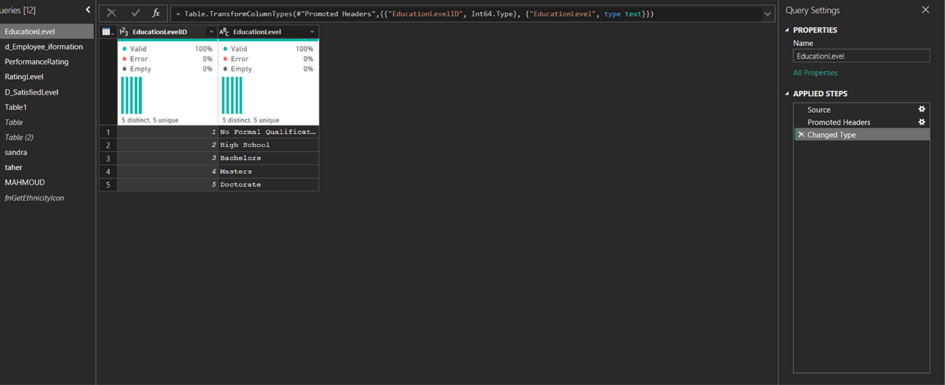
- Employee Information Table :`
- Source
The employee dataset is imported from the source.
- Promoted Headers
The first row is promoted to column headers (FirstName, LastName, Gender, Age, etc.).
- Changed Type
Data types are assigned:
EmployeeID → Text
Age → Number
BusinessTravel → Text - Department → Text
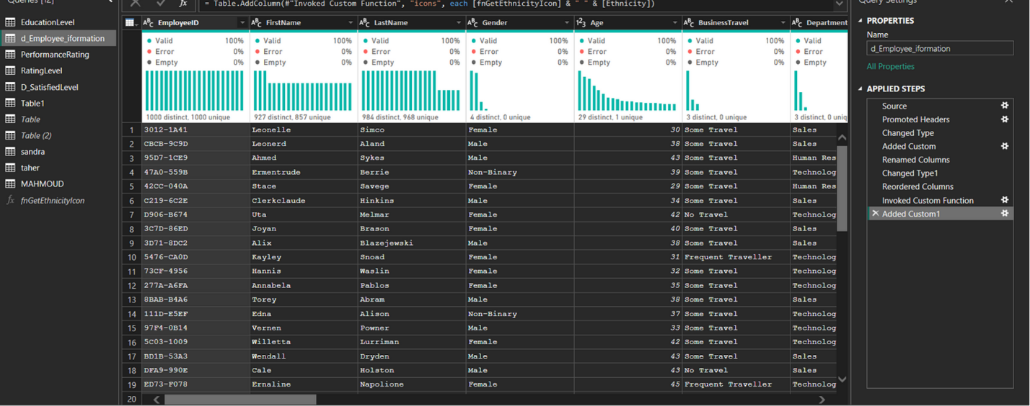

- Performance Rating Table:
- Source
The data is imported from the original source (Excel, CSV, or database).
This produces a raw table containing the columns exactly as they appear in the source file.
- Promoted Headers
Converts the first row into column headers.
Typically, this row contains names such as PerformanceID, EmployeeID, ReviewDate, etc.
- Changed Type
  - Power Query automatically assigns data types to each column.
    - ReviewDate → Date
    - RatingID → Whole Number
    - EnvironmentSatisfaction → Whole Number
- Renamed Columns
Some columns were renamed to more meaningful or standardized names that better suit the data model.
- Filtered Rows
Filters were applied (such as removing null values or invalid entries).
You may have filtered specific years or valid values only.
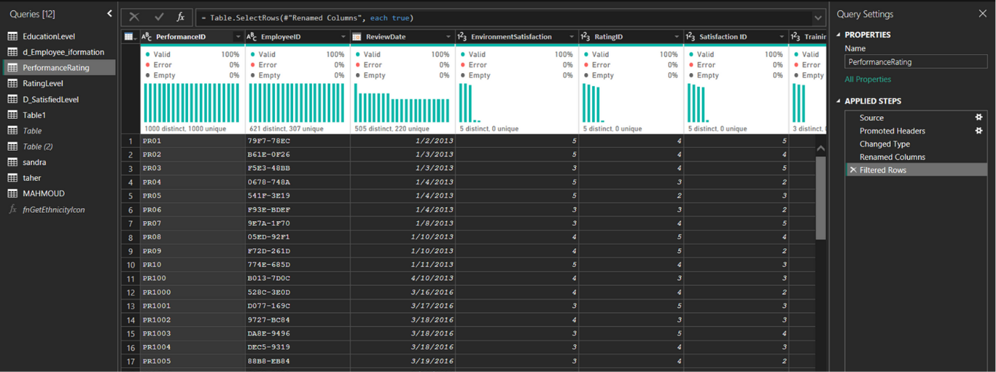

- Rating Level Table:
- Promoted Headers
Convert the first row into column headers:
RatingID - RatingLevel
- Changed Type
    - RatingID → Number
    - RatingLevel → Text
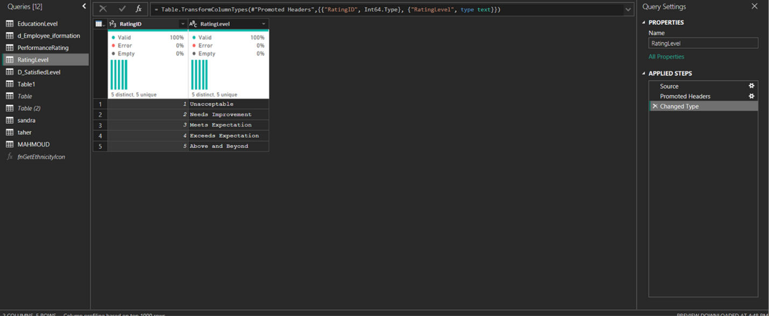

- Satisfied Level Table:
- Promoted Headers
Convert the first row into column headers.
The columns become: SatisfactionID - SatisfactionLevel
- Changed Type
Change the data type for each column:
SatisfactionID → Number (Int64)
SatisfactionLevel → Text
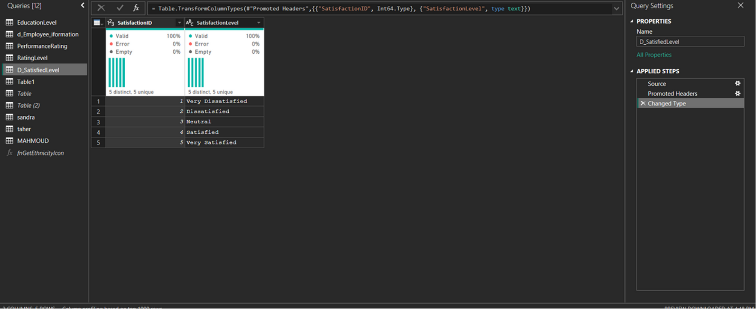

4.4 Data Modeling
Establishing relationships between fact and dimension tables.
Structuring the data model into a star schema for efficiency.
Building DAX measures to calculate KPIs such as:
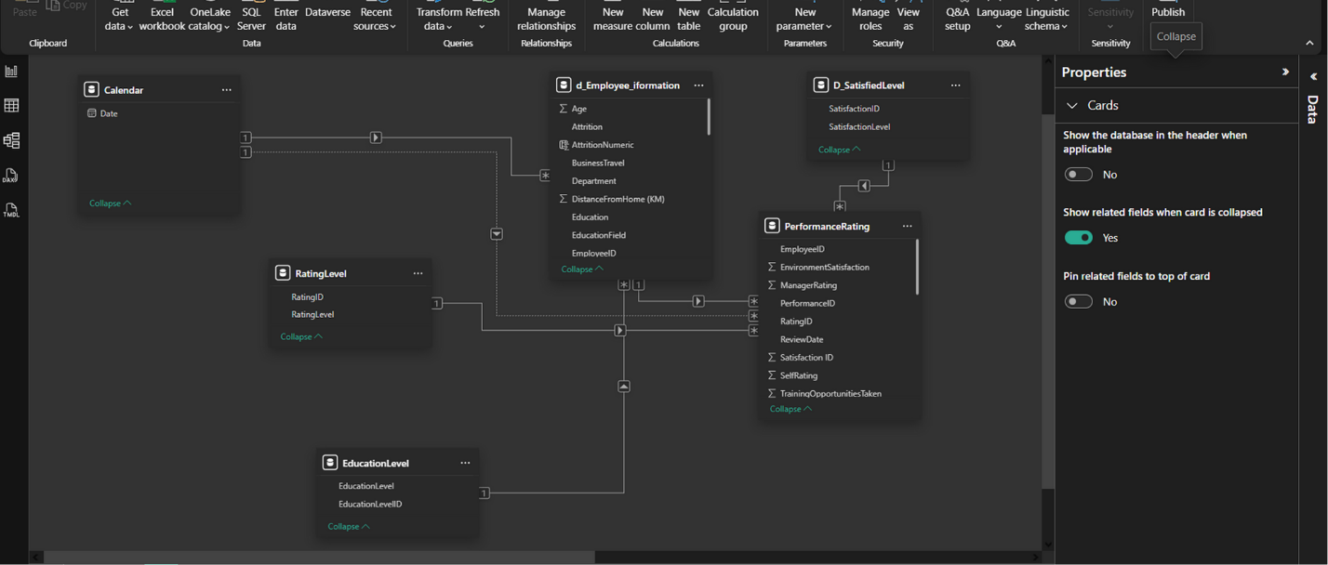

4.5 Creating Measures using DAX:
1. Males Expression: COUNTROWS(FILTER('d_Employee_iformation', d_Employee_iformation[Gender] = "Male")) Purpose: Counts the number of male employees.
2. females Expression: COUNTROWS(FILTER('d_Employee_iformation', d_Employee_iformation[Gender] = "Female")) Purpose: Counts the number of female employees.
3. total salary Expression: SUM(d_Employee_Information [Salary]) Purpose: Calculates the total salary for all employees.
4. Active_Employees Expression: CALCULATE(COUNT(d_Employee_iformation[EmployeeID]), d_Employee_iformation[Attrition] = "No") Purpose: Counts the number of active employees (those who have not left the company).
5. Active_Employees_Percentage Expression: DIVIDE( CALCULATE(COUNT(d_Employee_iformation[EmployeeID]), d_Employee_iformation[Attrition] = "No"), COUNT(d_Employee_iformation[EmployeeID]) ) Purpose: Calculates the percentage of active employees out of the total employees.
6. BACHELORS Expression: CALCULATE(COUNTROWS(d_Employee_Information), EducationLevel[EducationLevel] = "Bachelors") Purpose: Counts employees whose education level is Bachelor's degree.
7. Doctorate Expression: CALCULATE(COUNTROWS(d_Employee_Information), EducationLevel[EducationLevel] = "Doctorate") Purpose: Counts employees with a Doctorate degree.
8. High School Expression: CALCULATE(COUNTROWS(d_Employee_Information), EducationLevel[EducationLevel] = "High School") Purpose: Counts employees whose education level is High School.
9. Master's Expression: CALCULATE(COUNTROWS(d_Employee_Information), EducationLevel[EducationLevel] = "Master's") Purpose: Counts employees with a Master’s degree.
10. No Formal Qualifications Expression: CALCULATE(COUNTROWS(d_Employee_Information), EducationLevel[EducationLevel] = "No Formal Qualifications") Purpose: Counts employees with no formal educational qualifications.
11. HR_Rating_Count (the one using RatingLevel + HR filter) Expression: CALCULATE( COUNT(RatingLevel[RatingLevel]), FILTER(d_Employee_iformation, d_Employee_iformation[Department] = "Human Resources") ) Purpose: Counts rating entries for employees working in the Human Resources department.
12. Total Employees Expression: COUNT(d_Employee_iformation[EmployeeID]) Purpose: Counts the total number of employees.
13. Attrition_Employees Expression: CALCULATE(COUNT(d_Employee_iformation[EmployeeID]), d_Employee_iformation[Attrition] = "Yes") Purpose: Counts employees who have left the company.
14. Attrition_Percentage Expression: DIVIDE([Attrition_Employees], [Total Employees]) Purpose: Calculates the percentage of employees who left the company.
15. Average Rating Expression: AVERAGE(RatingLevel[RatingID]) Purpose: Calculates the average rating score.

4.6 Dashboard Execution:
Designing the interactive dashboard visuals.
Filtering mechanisms (slicers) for department, age group, salary slab, job role, etc.

The Employee Overview Dashboard: This dashboard provides a comprehensive snapshot of the workforce across key demographics and organizational dimensions. It consolidates employee counts, gender distribution, travel behavior, departmental structure, and marital status to support strategic HR decision-making.
The visuals combine summary cards, bar charts, and donut charts to give leaders a balanced and clear understanding of employee distribution patterns across the company.

Key Performance Indicators (KPIs):
1. Total Workforce  - Total Employees: 1,470  - Male Employees: 651  - Female Employees: 675  - Non-Binary: 124  - Prefer Not to Say: 20  2. Distance to Work  - Minimum Distance: 1 km  - Maximum Distance: 45 km  3. Marital Status Distribution  - Married: 624  - Single: 549  - Divorced: 297 | 4. Business Travel Activity  - Some Travel: ~70.95% (~1,000 employees)  - Frequent Travel: ~18% (~260 employees)  - No Travel: ~10.2% (~150 employees)  5. Employee Distribution by Department & Gender  Technology Department:  - Female: 438  - Male: 384  - Non-Binary: 84  - Prefer Not to Say: 16 | Sales Department:  - Female: 204  - Male: 183  - Non-Binary: 35  - Prefer Not to Say: 3  Human Resources:  - Female: 33  - Male: 24  - Non-Binary: 5  - Prefer Not to Say: 1

Recommendations:
1. Strengthen Diversity & Inclusion Programs
There is healthy gender representation, but non-binary and “prefer not to say” responses indicate a need for clearer inclusion policies or more confidence in disclosure.
Conduct internal surveys to understand inclusion perceptions.
2. Review Travel Policies
With over 70% traveling, consider:
Streamlining business travel approvals
Offering flexible travel alternatives
Monitoring travel-related fatigue and burnout

3. Optimize Workforce Distribution
Technology and Sales show high employee concentrations.
Assess workload balance, especially where one gender is dominant, to promote inclusive teams.
4. Address High Commute Distances
With travel distances reaching up to 45 km, consider:
Remote/hybrid work flexibility
Transportation allowances
Shuttle or corporate transportation services
5. Support for Single & Divorced Employees
Large single and divorced segments may benefit from:
Wellness programs
Work–life balance initiatives
Social support activities
6. Future Dashboards to Add
Attrition rate
New hires vs. exits
Performance rating overview
Training and development participation

The Salary & Overtime Dashboard: This dashboard provides a detailed financial overview of employee compensation patterns across job roles, gender groups, and time periods.
It also highlights the distribution of employees working overtime, enabling HR and finance teams better to manage workload balance, staffing costs, and budgeting.
The dashboard combines bar, trendline, and donut charts to provide insights into total salaries paid, overtime participation, and historical salary trends.

1. Total Salary Expenditure  - Total Salary Paid: 166M  2. Salary by Gender  - Female: 77M  - Male: 73M  - Non-Binary: 14M  - Prefer Not to Say: 3M | 3. Salary by Job Role (Top Contributors)  - Sales Executive: 38M  - Engineering Roles: 21M  - Machine Learning Specialist: 19M  - Analytics Manager: 18M  - Senior Software Engineers: 17M  - Software Engineers: 15M  - Data Scientists: 15M | 4. Employee Overtime Participation  - No Overtime: 71.7% (~1,000 employees)  - Yes Overtime: 28.3% (~400 employees)  - 5. Salary Trend Over the Years  - Peak salaries: 6.4M, 5.4M, 5.1M, 4.9M  - Lowest year value: 1.8M
Key Performance Indicators (KPIs):
- This indicates fluctuating salary spending over time with noticeable peaks and dips

Recommendations:
1. Assess Gender Pay Patterns
Female and male salary totals are close (77M vs 73M), but deeper analysis is needed to ensure:
Equal pay within the same job roles
No systemic pay gaps in promotions or bonuses
Transparent compensation policies
2. Monitor High-Cost Job Roles
Sales Executives account for 38M — significantly higher than any other role.
Recommended actions:
Evaluate commission structures
Validate productivity and ROI
Review compensation competitiveness for engineering and analytics roles to support talent retention

3. Manage Overtime More Effectively
With 28.3% employees working overtime, this may indicate:
Workload imbalance
Staff shortages in certain departments
Long-term risk of burnout
Suggested actions:
Improve workforce planning
Introduce overtime limits
Offer flexible scheduling or shift rotations
Automate repetitive workflows where possible
4. Stabilize Salary Fluctuations Over Time
The salary trend shows significant ups and downs, suggesting:
Seasonal hiring patterns
Inconsistent bonus or overtime strategies
Project-driven cost spikes

The Departmental Insights Dashboard: This dashboard provides a comprehensive analytical view of key performance metrics across the Technology, Sales, and Human Resources departments.
It highlights rating distributions, employee performance comparisons between self-ratings and manager ratings, average commuting distances, and departmental headcounts.
The dashboard also tracks yearly transportation allowances, offering a financial perspective on employee benefits.
Through visual insights—including stacked rating charts, bar graphs, and time-series financial trends—the dashboard supports strategic HR planning, workforce management, and performance evaluation.

1. Average Ratings  Average Self-Rating (All Departments): ~53%  Average Manager Rating (All Departments): ~46%  Difference: ~7% higher employee self-rating  2. Department-Level Rating Metrics  Human Resources:  Average Self Rating: 3.99  Average Manager Rating: 3.44  Technology Department:  Rating levels approx: 984, 1090, 1059, 1040 (total 4.18K)  Sales Department:  Rating levels approx: 515, 517, 518, 558 (total 2.23K)  HR Department:  Rating levels approx: 303 total | 3. Average Distance From Home (KM)  Sales: 23.13 km  Technology: 22.26 km  Human Resources: 21.70 km  Differences between departments are minimal (<2 km)  4. Department Size (Total Employees)  Technology: 4.81K employees  Sales: 2.23K employees  Human Resources: 0.32K employees  5. Transport Allowances Over Time  Total Transport Allowance Paid: $231.55K  Yearly range: $18K – $30K  The trend shows a gradual increase toward 2022
Key Performance Indicators (KPIs):

Recommendations:
1. Address the Gap Between Self & Manager Ratings
Employees consistently rate themselves higher than managers do (≈7% difference).
This may indicate:
Misalignment in performance expectations
Insufficient feedback frequency
Lack of standardized evaluation criteria
Recommendation:
Implement calibration sessions and training for managers to ensure consistent rating standards.
2. Strengthen HR Department Capacity
HR has the smallest workforce (320 employees) compared to Technology (4.8K) and Sales (2.2K).
A small HR team supporting a large workforce may lead to:
Overload on HR staff - Slower issue resolution - Higher risk of employee dissatisfaction
Recommendation:
Evaluate HR staffing levels and automate repetitive HR tasks using HRIS systems.
3. Address High Commute Distances
Average distances (~22–23 km) may contribute to:
Fatigue
Lower punctuality
Higher turnover risks
Recommendation:
Introduce:
Partial remote-work options
Transport stipends (already tracked)
Shuttle services for peak routes
4. Continue Monitoring Transport Allowances
The allowances show fluctuations but a general upward trend toward $25K–$30K.
This increase may be tied to:
Inflation
Fuel prices
Growth in employee count
Recommendation:
Regularly reassess transport allowances to maintain fairness and cost control.
5. Explore Rating Level Patterns
Technology has the largest number of employees across all rating levels.
Sales have a moderate distribution, while HR is significantly lower.
Recommendation:
Use these patterns to: -Identify training needs and track high-performer clusters
-Plan promotions and succession pipelines
-Use export options if the user needs PDF or image versions of the charts.
-Navigate through multiple dashboard pages to explore attrition, employee demographics, and KPIs.
-Hover over charts for detailed tooltips and insights.
.9

The Education Level Dashboard: This dashboard provides a detailed breakdown of employee qualifications, salary levels by education background, and workforce trends by marital status over time.
It gives HR and management a clear understanding of how education impacts compensation, how employees are distributed across education tiers, and how demographic patterns evolve annually.
The dashboard combines qualification counts, salary analysis by education level and field, and longitudinal demographic trends, enabling smarter talent planning, compensation strategy optimization, and workforce forecasting.

Key Performance Indicators (KPIs):

1. Employee Count by Education Level  No Formal Qualification: 170  High School: 282  Bachelors: 572  Masters: 398  Doctorate: 48  Total = 1,470 employees (matches other dashboards)  2. Average Salary by Education Level  Doctorate: 154K (highest)  Masters: 118K  Bachelors: 115K  High School: 105K  No Formal Qualification: 95K (lowest)  Clear positive correlation: Higher qualification = higher salary. | 3. Average Salary by Education Field  Top-earning fields:  Human Resources: 145.57K  Marketing: 124.28K  Information Systems: 114.38K  Economics: 112.22K  Computer Science: 109.35K  Lower salary fields:  Business Studies: 98.41K  Other Fields: 96.34K  Technical Degrees: 94.87K  4. Marital Status Trend Over Years (2013–2022)  Married employees consistently dominate (≈55%+ each year)  Single employees represent ~25–35%  Divorced employees are the smallest group (~15–25%)  Significant increase noted in 2022:  Married: 105  Single: 37  Divorced: 13

Strategic Recommendations:
1. Develop Advanced Education Incentive Programs
Doctorate and Master's holders show substantially higher salaries, but they are limited in number (48 and 398).
To increase expertise and strengthen the organization’s capability:
✅ Offer tuition reimbursement
✅ Support professional certifications
✅ Create career ladders tied to education or skill advancement
2. Optimize Compensation Strategy by Education Field
Some fields (HR, Marketing, Information Systems) demonstrate higher salary demand.
Recommendation:
- Align future hiring with compensation benchmarks
- Review pay for fields currently undervalued, like Technical Degrees and Business Studies
- Ensure internal equity across education fields
3. Strengthen Workforce Development at Lower Education Levels
Employees with High School and No Formal qualifications earn the lowest salaries.
Recommendation:
- Provide targeted upskilling programs
- Create pathways for promotion through skill-based training
- Offer partnerships with technical institutes
-> This helps reduce turnover and increase employee satisfaction.
4. Monitor Shifts in Marital Status Trends
The upward trend in married employees may imply:
Higher demand for family-related benefits
Need for stability-focused retention plans
Potential for higher benefit cost structures

Recommendation:
- Review family insurance, parental leave, and flexible schedule policies
- Forecast workforce demographics to support benefits budgeting
5. Recruit Strategically Using Education-Salary Insights
Fields like HR, Marketing, and IS have higher salary expectations.
Recommendation:
- Use dashboard insights to adjust recruitment budgets
- Evaluate if higher-earning fields correlate with higher performance or business impact
- Direct recruitment investment toward fields with the best ROI

Attrition & Retention Dashboard: This dashboard provides a comprehensive view of employee attrition and retention across the organization. It visualizes key workforce metrics—including total employees, active vs. attrition counts, demographic distribution, and attrition trends—allowing HR and management to assess the stability, diversity, and satisfaction of the workforce.
It highlights which employee groups and salary ranges are most at risk, identifies departments with higher turnover, and evaluates how tenure varies across different age groups. The dashboard supports strategic workforce planning and helps target interventions to improve employee retention.

1. Total Employees  1470 employees  Represents the full workforce size.  2. Total Attrition (Employees who left)  237 employees  Attrition Rate: 16%  Indicates a moderate turnover level that should be monitored.  3. Active Employees  1233 employees (84%)  Shows the current workforce after accounting for attrition.  4. Attrition by Salary Range  Highest attrition: 0–100K salary range (0.20)  Attrition decreases as salary increases, ending around 0.08 for 300K–400K range  Indicates lower-salary employees are more likely to leave.  5. Attrition by Department  - Sales: 0.21 (Highest)  - HR: 0.19  - Technology: 0.14 (Lowest)  - Sales is a critical turnover hotspot. | 6. Attrition by Ethnicity  Major categories displayed include:  White (860 employees)  African American (207)  Mixed / Multiple groups (198)  Asian (113)  Total attrition is 237, distribution visible by ethnicity.  Useful to detect diversity-related retention gaps.  7. Average Years at Company  Overall Average Tenure: 4.56 years  Tenure rises with age and peaks around ~40 years old (7–9 years).  Sharp drop again after age 50.  Insights & Notable Observations  Younger employees have lower tenure, likely early exits or frequent job changes.  Sales department shows significantly higher attrition, suggesting workload, targets, or compensation issues.  Lower salary bands have higher attrition, indicating financial dissatisfaction or competitive market pull.  Most employees stay 4–9 years, especially mid-age groups (30–45).  Demographics remain relatively stable but could hide underlying disparities.
Key Performance Indicators (KPIs):

Actionable Recommendations:
1. Improve Retention for Lower-Salary Employees
Review compensation packages for salary ranges under 100K.
Introduce performance bonuses or career advancement pathways.
Offer training and certifications to increase internal promotion opportunities.
2. Targeted Intervention in Sales Department
Conduct exit interviews to identify root causes (excessive KPIs, pressure, commission issues).
Introduce employee wellness and sales support tools.
Rebalance workloads or adjust commission structures.
3. Strengthen Early-Career Employee Engagement
Create a structured onboarding and mentorship program.
Provide clearer career progression for new hires.
Increase recognition and development opportunities during the first 2 years.
4. Monitor Demographic-Based Attrition
…………………………………………………………………………………………………………………………………………………………………

